CS 255 System Design Document Quinn

UML Diagrams

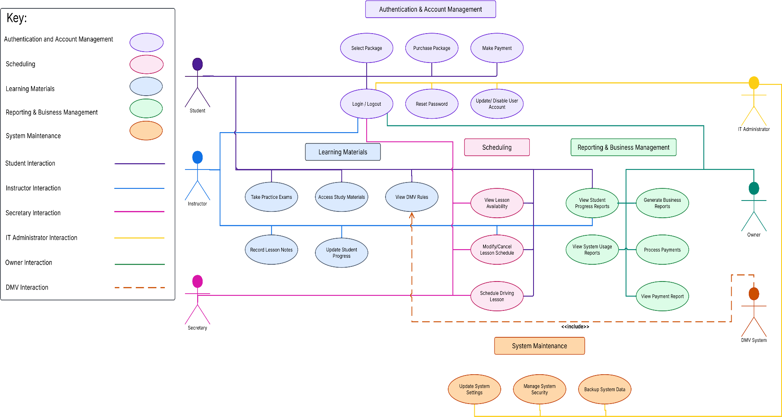
UML Use Case Diagram

UML Activity Diagrams
Purchase Package
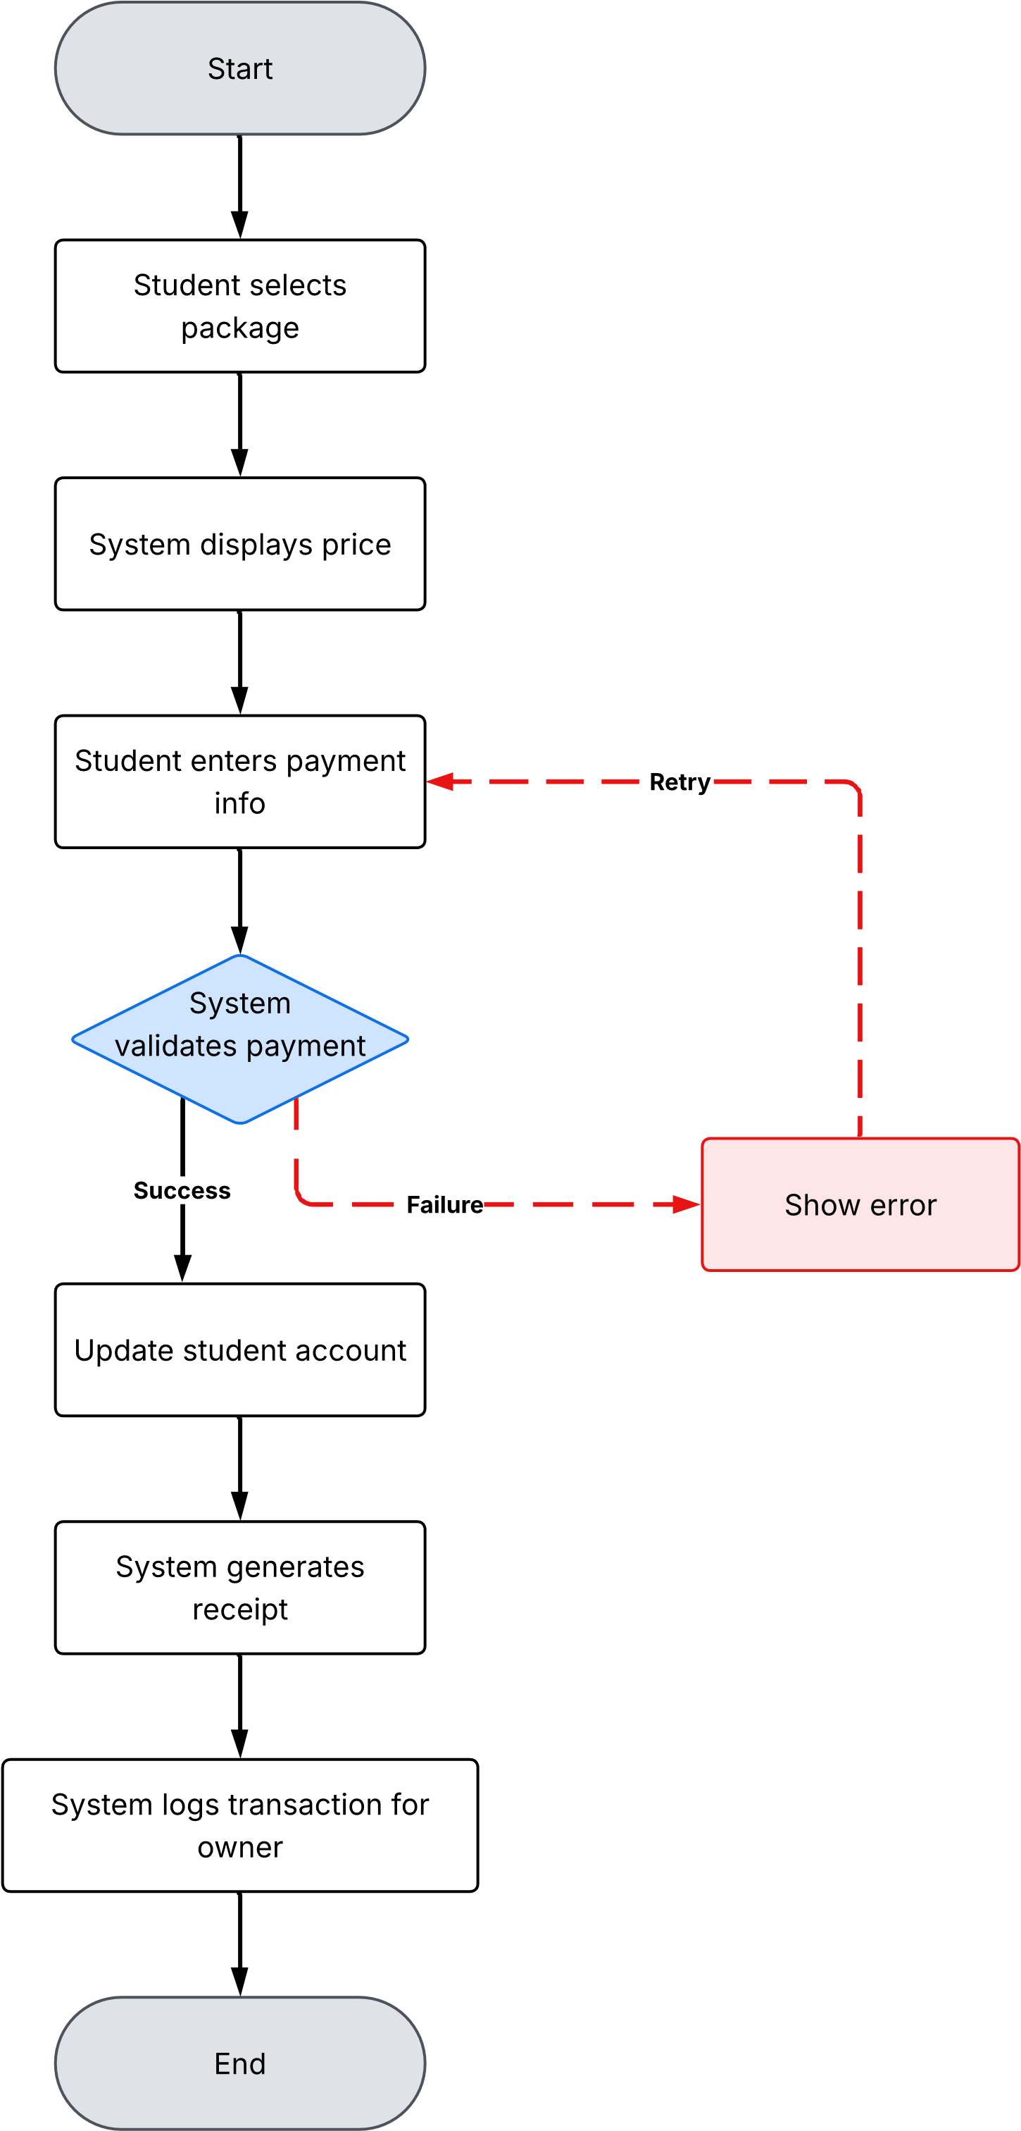

Schedule Driving Lesson
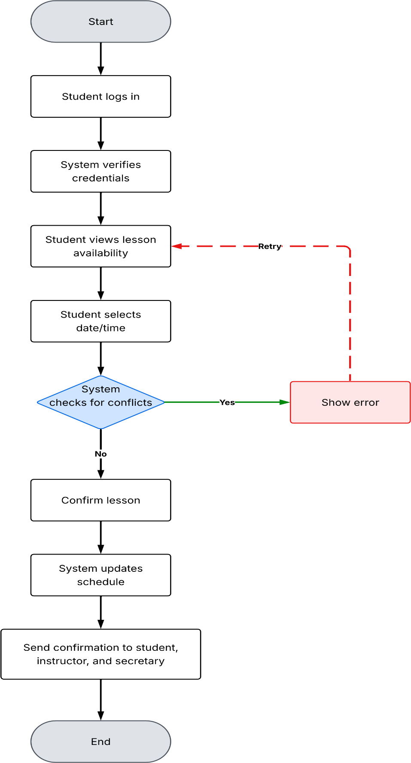

UML Sequence Diagram
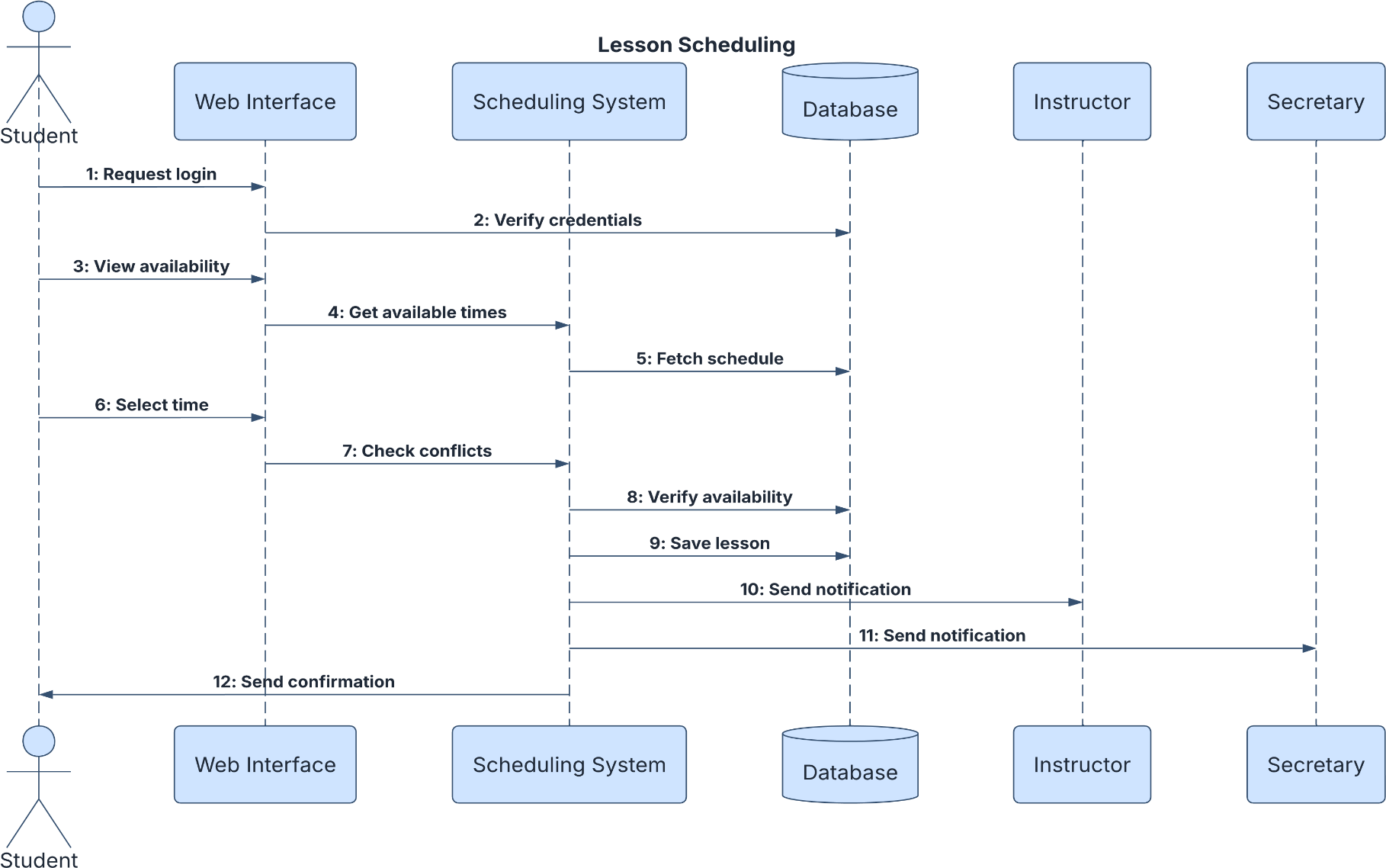

UML Class Diagram

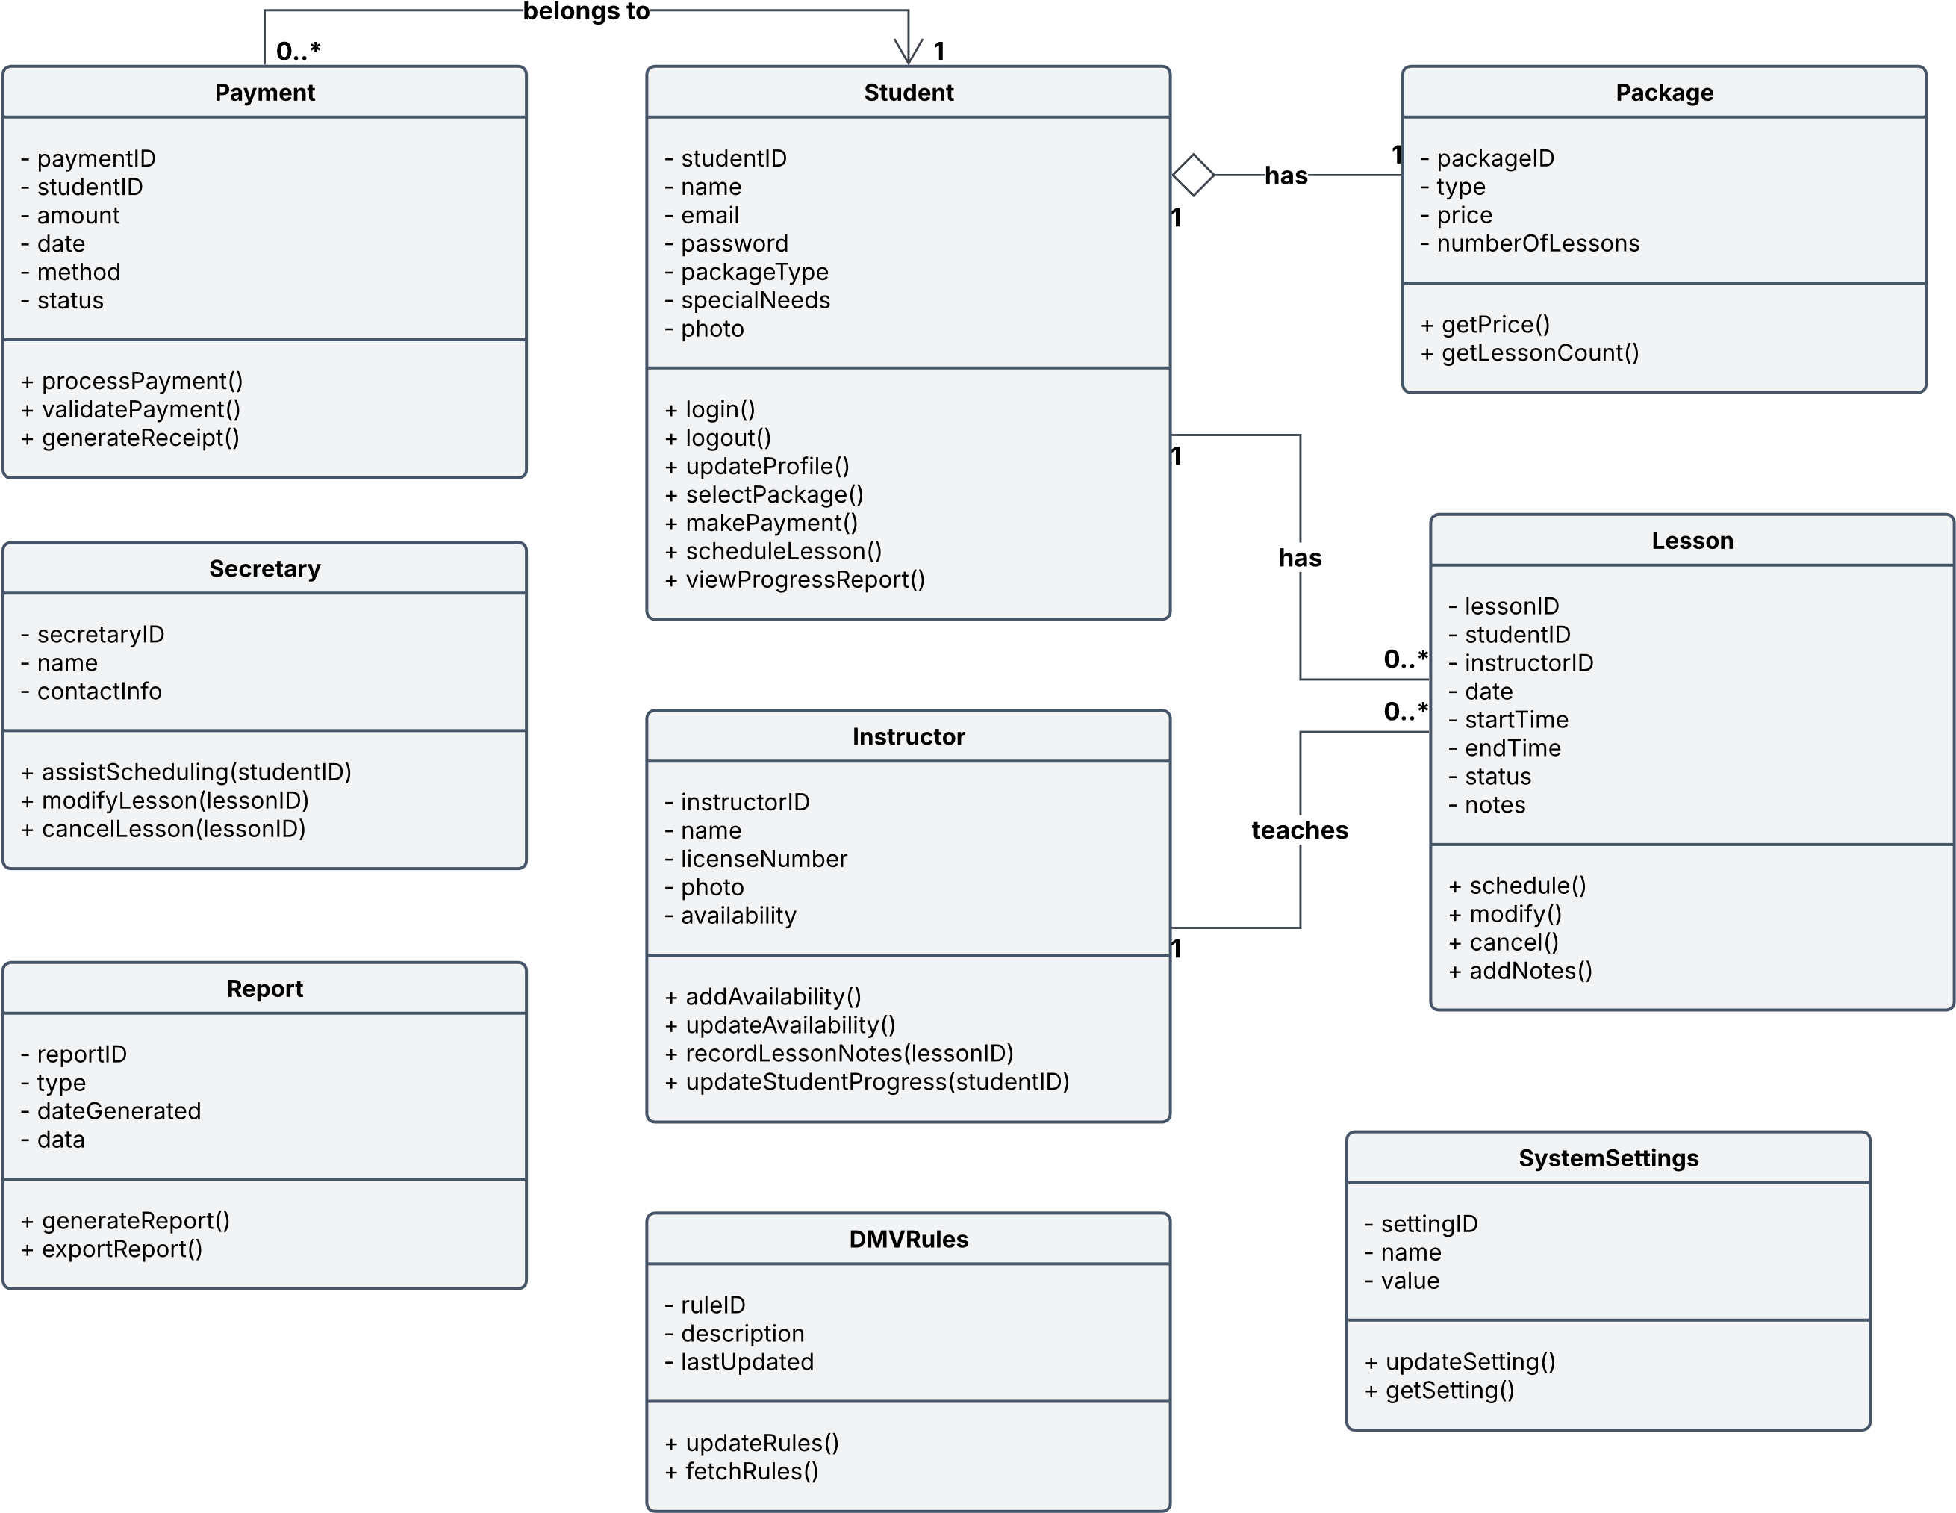

Technical Requirements
Hardware
The DriverPass system has server and client hardware requirements for a fully functioning system. Server hardware requirements include a multi-core CPU with 4 - 8 cores minimum to support scheduling, user authentication, and reporting. A minimum of 16-32 GB RAM is required to handle multiple user interactions at the same time. Another hardware requirement is at least 500 GB SSD storage, or more for user accounts, scheduling lessons, instructor notes, payment records, and DMV updates. For the client hardware requirements, they need a device that can run a modern web browser.
Software
In addition to the hardware requirements, there are a lot of software requirements as well. The server operating system will need Windows Server, and the client operating system will need either Windows, macOS, iOS, Android, or ChromeOS. For the web application, the system requires a web framework to run the web interface. The system will also require a relational database such as MySQL for database requirements with students, instructors, lessons, packages, payments, reports, DMV rules, and system settings tables. This is needed to verify login credentials and save lessons. Another software requirement is to process payments they system needs to be integrated with PayPal or Square. The system requires role-based access control for security, so password resets and account updates are only available to specific users. SSL/TLS encryption is also required to protect information between the server and browser. Cloud backup storage is required for system data backups.
Tools
Different tools are required for the creation and functionality of the system. Lucidchart is required to design the system using UML models. Azure DevOps is required for collaboration, version control, and team communication. To develop the DriverPass system, tools such as Visual Studio are required to build the web interface and the backend of the system. A browser developer tool is also required to test the web interface. Another necessary tool is Postman to test API calls to keep the DMV rules updated. A web application framework like Django is also required for web-based login and instructor note updates. A SQL database tool is needed to verify login information, save lessons, generate reports, store packages, and fetch schedules. A payment processing tool like PayPal API or Square Payments API is required to handle secure payments and generate receipts. Security tools like SSL/TSL certificates and firewalls are required to protect information in the system. Cloud tools like Azure App Service for hosting the web application. Azure SQL hosts the database for the system. Azure Monitor handles the system usage monitoring. Azure Backup is required to handle backing up the system. As well as a reporting tool like Azure Log Analytics is also required to generate reports.
Infrastructure
There are also technical requirements for the infrastructure of the system. Load Balancing is required for scheduling, getting reports, and processing payments to ensure availability and performance. API integration is required to update the DMV rules. Networking requirements include good internet and a firewall. Reporting infrastructure requires a reporting engine and a central logging system, so all information is accessible.

References

GeeksforGeeks. (2026, September 28). Introduction to API (Application Programming Interface). GeeksforGeeks. https://www.geeksforgeeks.org/software-testing/what-is-an-api/

Hardware components in web servers. B. Com Institute. (2026, September 2). https://bcom.institute/e-commerce/hardware-components-web-servers/

What is Azure? | Microsoft Azure. Microsoft. (n.d.). https://azure.microsoft.com/en-us/resources/cloud-computing-dictionary/what-is-azure

